Experiment: 10
5G Network Slicing Environment Using MATLAB
Aim
To analyze the performance of a 5G Network Slicing environment by studying the number of network slices, slice utilization, and end-to-end latency using MATLAB.
Objectives
Objective – 1: Analyze the Number of Network Slices
Analyze the creation and allocation of multiple network slices in a 5G network using MATLAB. Observe how different slices can be configured to support diverse service requirements and applications.
Objective – 2: Compare Slice Utilization (%)
Compare the utilization of different network slices using MATLAB. Analyze how efficiently network resources are allocated and utilized across multiple slices.
Objective – 3: Analyze End-to-End Latency (ms)
Analyze the end-to-end latency of different network slices using MATLAB. Compare the latency values to understand the Quality of Service (QoS) requirements of various 5G applications.
Software Required
- MATLAB
Theory
Network slicing is a key feature of 5G that enables a single physical network infrastructure to be partitioned into multiple logical networks called slices. Each slice is optimized for a specific
service category, such as enhanced Mobile Broadband (eMBB), Ultra-Reliable Low-Latency Communications (URLLC), or massive Machine-Type Communications (mMTC). By
dynamically allocating network resources, network slicing improves flexibility, resource utilization, and Quality of Service (QoS) while supporting diverse application requirements. Objective – 1

Analyze the Number of Network Slices
Generate and visualize multiple network slices using MATLAB. Observe how a 5G network can be logically partitioned into independent slices for different communication services.

Objective – 2
Compare Slice Utilization (%)
Analyze the utilization percentage of different network slices using MATLAB. Compare the resource usage of each slice to evaluate network efficiency.
Objective – 3
Analyze End-to-End Latency (ms)
Compare the end-to-end latency of different network slices using MATLAB. Observe how latency varies depending on the service requirements of each slice.

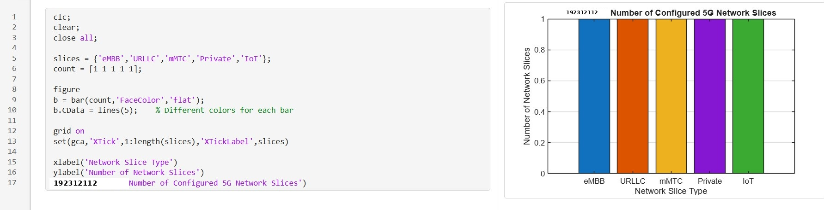
Output

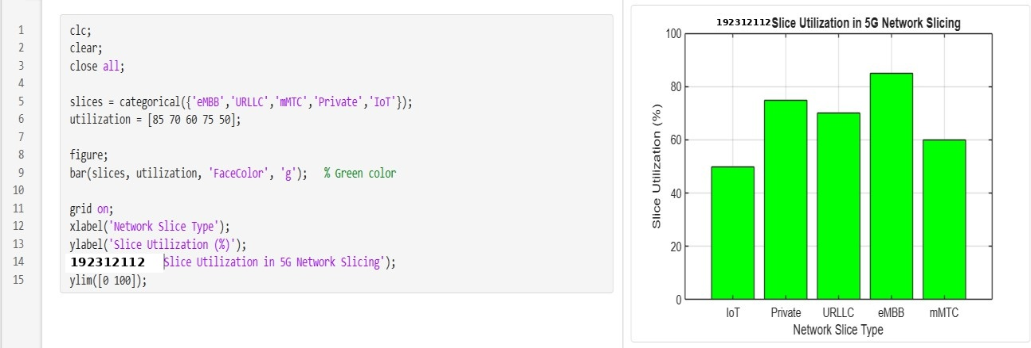

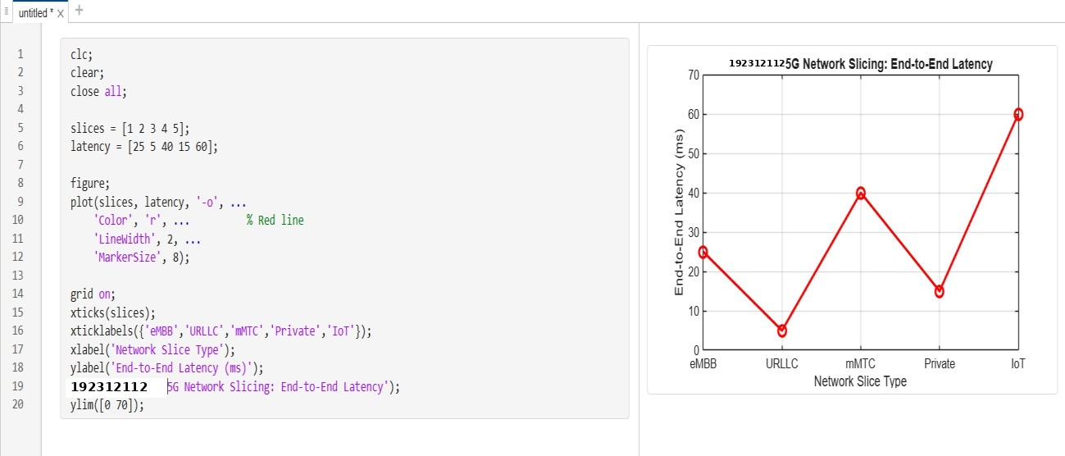
Result
Line graph showing end-to-end latency for different network slices.
The MATLAB analysis successfully demonstrated the characteristics of a 5G Network
Slicing environment. The results showed that multiple network slices can coexist while exhibiting different utilization levels and latency characteristics based on their intended services

